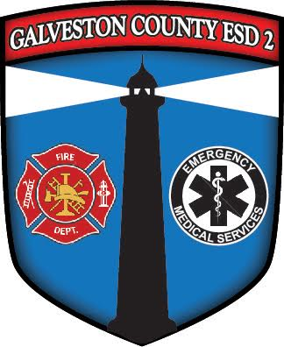Bolivar Peninsula Residients | - Cost  - $5.00  - (non-Health CAre Provider)  - •
Classes to be held in High Island, Crystal Beach and Port Bolivar  Dates Time 6:00 to 8:00 pm Location  March 9th, 2020 Crystal Beach Fire Station  930 Noble Carl Drive  March 11th, 2020 High Island Fire Station  2041 7th Street  March 13th, 2020 Port Bolivar Fire Station  1806 Broadway Street  All classes start at 6:00 | 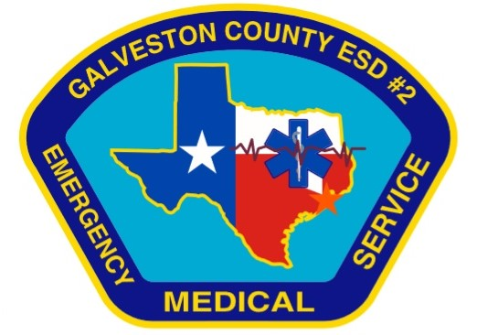  To Sign Up contact  409-684-2016

